Introduction
There are significant power requirements with the power input. Mainly the connector.
Requirements state that the connector should be a spring loaded terminal suitable to cables up to 10 mm².

Terminal selection
Theoretical maximum of all power outputs combined would be 120A. Considering that DefSecIntel states usual power consumption around 200W (~ 8 A at 24V) wire cross section area 10mm² is used as main parameter.

Wago 2616-1352 was selected.
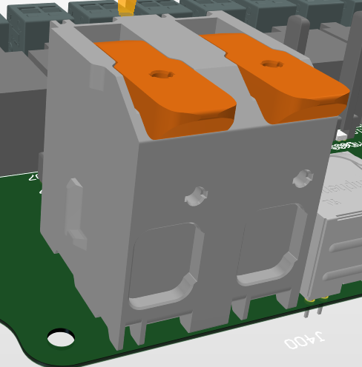
Figure 1: 3D Model of Wago 3616-1352
The maximum current for it is 76A.

Input protection
Overvoltage and overcurrent protection are not required, but transient voltage suppression is needed.
TVS diode with 33V working voltage is selected - SMAJ33A. This is meant to protect against short transient events like load drop at system output or inrush beak at system connection to battery.

Current management
It’s difficult to manage currents in the PCB on the copper traces alone. Copper busbars will be cut and soldered on the PCB.

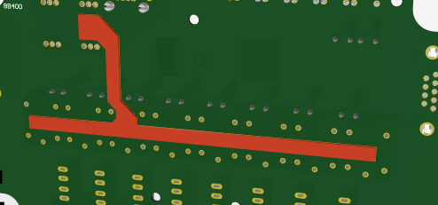
Figure 2: Power busbar

PCB toolkit model shows that 5mm wide and 1mm thick copper bar that’s 100 mm long can carry 64A when 20°C temperature rise is allowed.

Other way of estimating the power loss is trough copper resistivity. Resistivity is the resistance of 1m³ block of copper. It can be used with the following equation 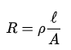
Copper resistivity | 1,68E-08 | Ω*m
Width | 0,005 | m
Height | 0,001 | m
Length | 0,1 | m
Piece resistance | 0,000336 | Ω

If 76A were to pass through this conductor voltage drop would be 0,026 V. Power dissipation would be 1,94W and this is acceptable considering that PCB size is 170 mm x 100mm.

Copper thickness can be increased if needed.

Also since all output currents are measured and safe global limit implemented trough that peak currents are only expected in a failure. Failure currents exceeding the maximums considered here are time limited to few seconds until fuse or software reacts.

Busbar is considered for return current as well. Copper cutouts will be used in ground network to direct large return currents away from digital portion of the PCB and onto the busbar.

